**COMPUTER NETWORKS - CSA07**

**Parthibhan .R**

**192224275**

**EXPRIMENT 12:-**

Smart Garden in Cisco Packet Tracer

Github Link:- <https://github.com/parthibhan007/CSA0748-computer-network/tree/main/expriment%2012>

Simulation:-

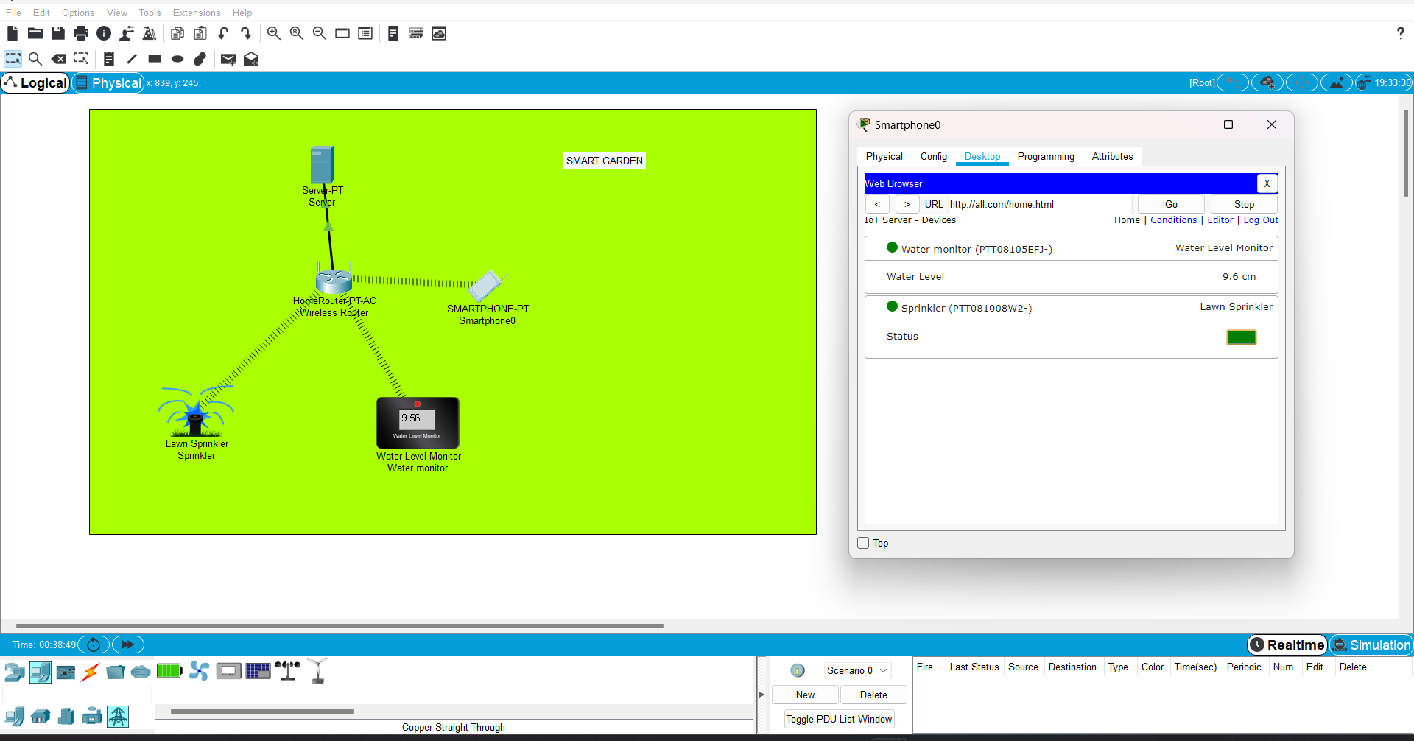

Condition:-

